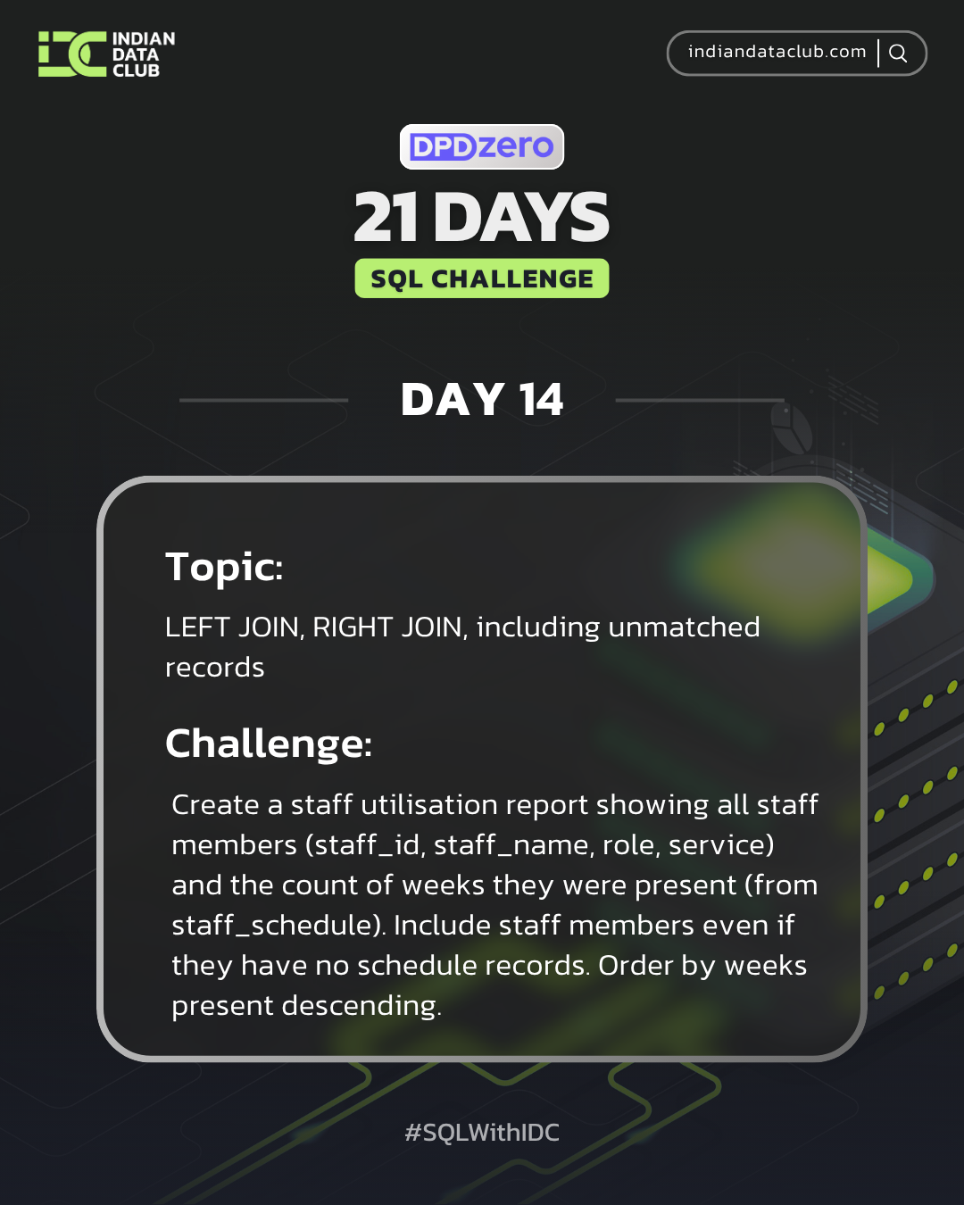

Day-14 SQL Challenge
Day 14 Challenge:
Create a staff utilisation report showing all staff members (staff_id, staff_name, role, service) and the count of weeks they were present (from staff_schedule). Include staff members even if they have no schedule records. Order by weeks present descending.
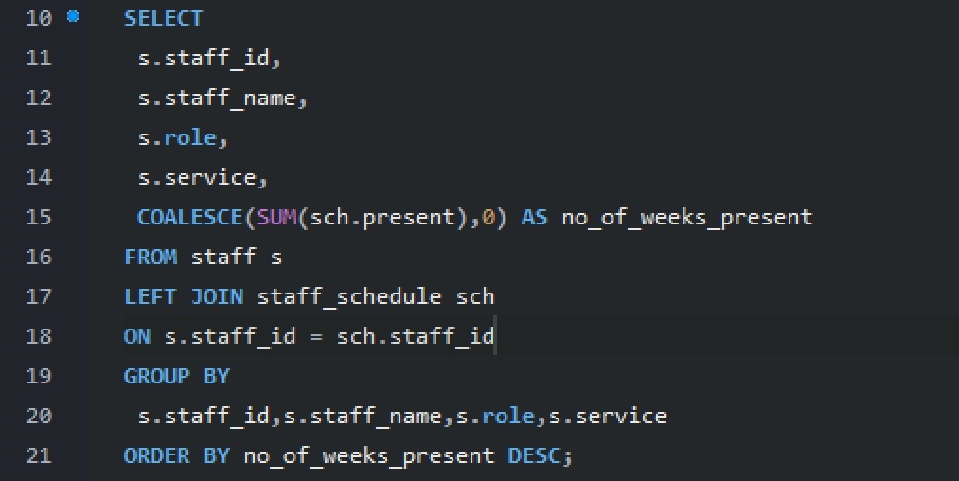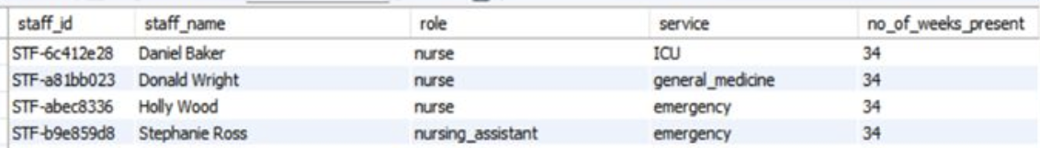

Practice Questions:
1. Show all staff members and their schedule information (including those with no schedule entries).
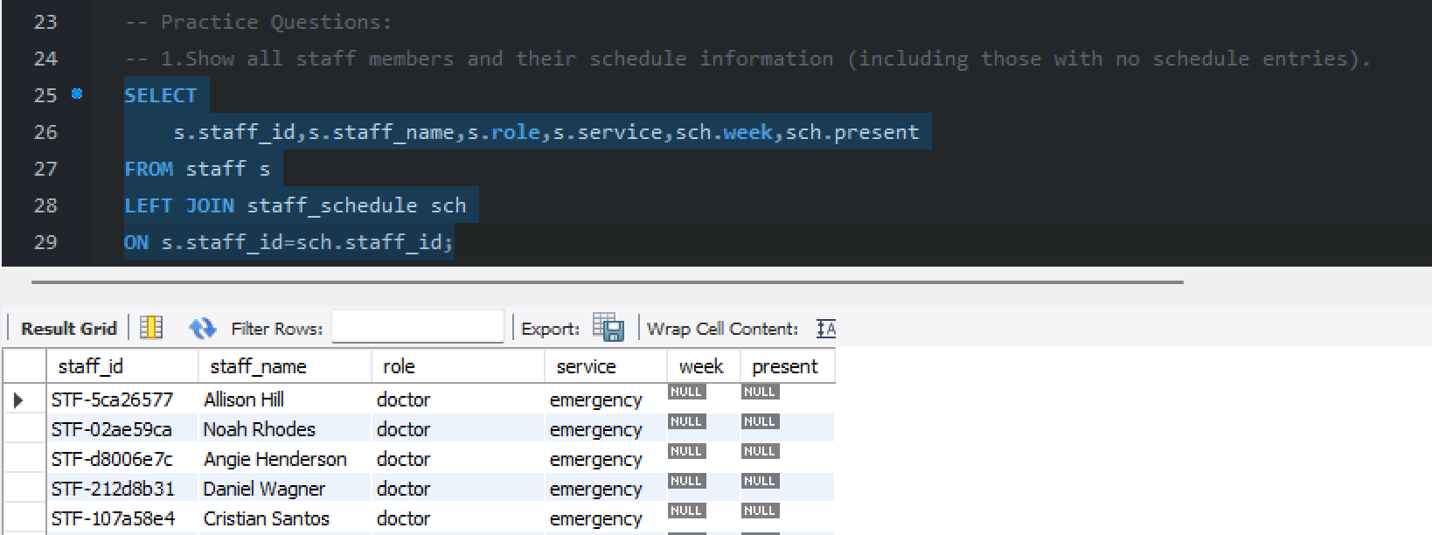
2. List all services from services_weekly and their corresponding staff (show services even if no staff assigned).
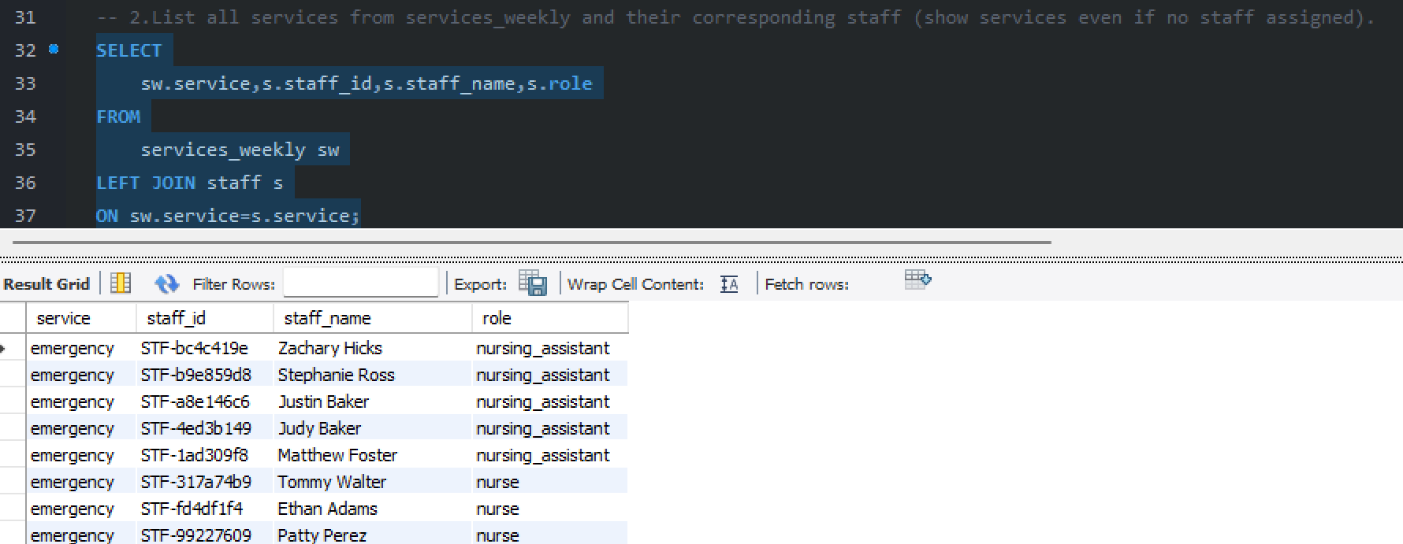

3. Display all patients and their service's weekly statistics (if available).
